Rédiger une intro un peu plus générale, parler des travaux du groupe de Nassia sur les souris.
In the muscles takes place the most intuitive example of mechanotransduction : when they exert or resist to forces, they tend to grow, whereas when immobilized or denerved, they shrink. This phenomenon requires a pathway from the mechanical cues to the genes, for the genetic program of muscle growth to be activated by exercise. Studies on mice have identified Serum Response Factor (SRF), along with its cofactors Myocardin-Related Transcription Factors (MRTF-A and B from the myocardin family) as the major transcription factor involved in mechanically-induced muscle growth regulation. Together, MRTF-A and SRF regulate the expression of cytoskeletal genes and muscle developpement genes in muscle cells. MRTF-A is an actin binding protein which can shuttle between the nucleus, where it can activate SRF, and the cytoplasm, depending on its link with monomeric actins. Guerci & al have shown in vivo that muscle fibers subjected to a mechanical overload can activate satellite cells through a actin/MRTF/SRF-regulated paracrine signalling, causing them to proliferate and fuse with the fibers, thus contributing to the growth of the muscles. In the case of a mechanically-induced atrophy, SRF is downregulated, leading to muscle loss. However, artificial activation of SRF or nuclear MRTF is sufficient to rescue the muscle from atrophy. Thus, the mechanotransduction between the forces exerted on the muscle and the growth is controlled through the interaction between the main component of the cytoskeleton, actin, and the cofactor of SRF, MRTF-A.
The relationship between G-actin and MRTF-A is well documented. MRTF-A binds 3 to 5 actin monomers through 3 RPEL repeats (posern 2004, mouilleron 2008, hirano 2011). The nuclear localization signal (NLS) is embedded inside the 3 RPEL (rajajyla 2010), thus making its availability dependent on G-actin binding. When actin is bound to MRTF-A, the NLS is hidden and MRTF-A is cytoplasmic (posern 2002 & 2004, miralles 2003), whereas when actin is scarce, the NLS is available and MRTF-A can accumulate in the nucleus. On the contrary, a G-actin scarcity in the nucleus has been shown to hinder MRTF-A exiting from the nucleus (baarlink 2012). The localization of MRTF-A in the cell is thus closely linked to the G-actin pool available to bind it and maintain it in the cytoplasm. Actin polymerizing drugs, such as jasplakinolide (miralles 2003, vartiainen 2007), highly polymerizable actin mutants (posern 2004) or actin sequestering drugs such as cytochalasin D deplete the G-actin pool and induce the transfer of MRTF-A to the nucleus. On the other hand, non polymerizable actin mutants (posern 2002, miralles 2003), actin over-expression (miralles 2003, vartiainen 2007) or latrunculin B, which is compatible with MRTF-A actin binding, participates in sequestering actin in the cytoplasm. While the role of biochemicals in this pathway has been widely studied, the influence of mechanical cues on the MRTF-A/SRF pathway through actin organization has been less investigated.
Mechanical cues are well known to induce reorganization of the actin cytoskeleton in a great variety of cell types and conditions (à voir dans Shao 2015). Both the mechanical properties of the substrate, and the forces (mechanical stresses?) and strains the cells are subjected to, can promote actin polymerization (Discher Science 2005, Chambliss 2013, Greiner 2013, Shao 2015). At the muscle level, MRTF-A and SRF have been shown to control the increase in muscle mass following a mechanical hyper-stimulation and the atrophy following an immobilization, linking through this pathway mechanical stimuli and genetic response (Guerci 2012, Collard 2014). Our purpose is thus to bring together those different pieces, from the mechanically induced cytoskeletal reorganization to the MRTF-A/SRF transcription pathway. The main questions we want to address are: What kind of mechanical cues are able to reorganize the actin cytoskeleton enough to induce changes in MRTF-A intracellular localization? What are the timescales involved?
To answer these questions, we used two different custom-built devices to apply mechanical stimuli at the cell level: we applied either a local force through fibronectin-coated micron-sized beads controlled by magnetic tweezers, or a global deformation through stretchable PDMS substrates. Both the localization of MRTF-A and actin polymerization were monitored through time thanks to fluorescence labellings.

Results
The subcellular localization of MRTF-A is correlated to its expression level and to the globular actin level

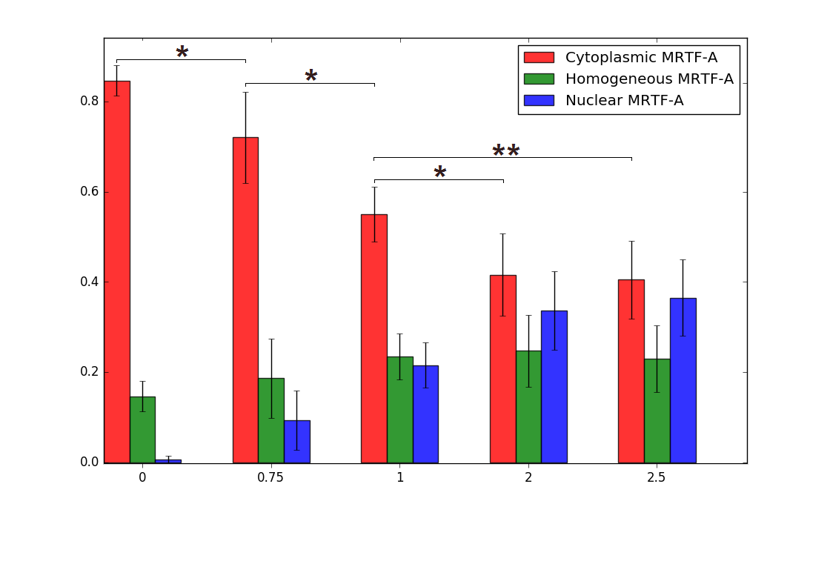
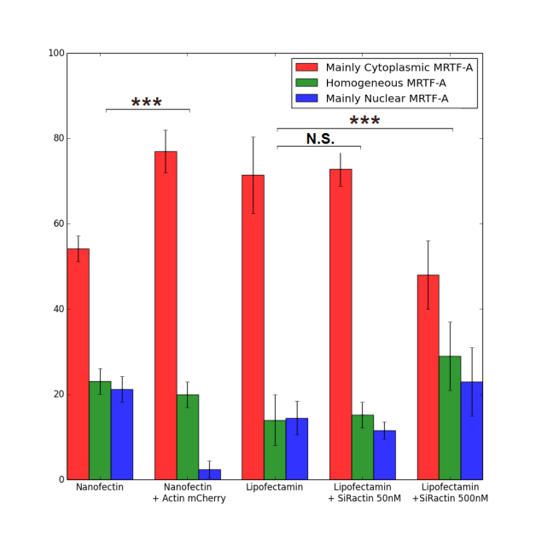
Figure 1 Localization of MRTF-A GFP (a) as a function of the mass of MRTF-A GFP plasmid DNA used for the transfection with nanofectine. More DNA leads to nuclear accumulation of MRTF-A due to its overexpression compared to the G-actin pool (0.75µg : 75 cells, 1.0µg 260 cells, 2.0µg : 113 cells, 2.5µg 126 cells); (b) as a function of transfection reagent, actin overexpression and F-actin stabilizing fluorescent marker SiRactin

As-tu des résultats fiables sur la localisation de l’endogène ?
(Après un recomptage sur les expériences endogènes du 18 et 19 juin 2014) : 85 ± 6 % C, 15 ± 7 % H, 0,7 ± 0,2 % N, n=2, 436 cell.
C2C12 myoblasts were transfected with a plasmid coding for MRTF-A-GFP. The localization of MRTF-A GFP in the cell was then observed by fluorescence microscopy, and the cells were classified between three categories according to the main localization of MRTF-A GFP signal: mainly cytoplasmic (“C”), mainly nuclear (“N”) or homogeneously distributed (“H”). Different levels of plasmid concentration were tested for transfection with Nanofectin, ranging from 0.75µg to 2.5µg of DNA for 110 000 cells. At the lowest level of plasmid, MRTF-A GFP is mainly cytoplasmic in more than 70% of the cells, whereas at the highest levels, the percentage of “C” cells drops to less than 40. The more plasmid is supplied, the more nuclear MRTF-A is. This is consistent with the mechanisms known for the regulation of MRTF-A intracellular organization through G-actin binding: when MRTF-A is overexpressed due to many plasmid copies, there are not enough G-actin monomers to bind it and maintain it in the cytoplasm. The excess in MRTF-A is thus free to accumulate in the nucleus. For the following experiments, we always used the 1µg of MRTF-A GFP DNA dose, as a compromise between sufficient transfection efficiency and low overexpression.
For better transfection efficiency, we also tried Lipofectamin 3000 with the same low MRTF-A GFP dosage (1µg DNA for 110 000 cells). In the same experimental conditions, the localization of MRTF-A GFP was significantly more cytoplasmic (p=3.10⁻⁴) while the transfection efficiency increased, from about 20% of cells expressing MRTF-A-GFP with Nanofectin to about 40% with Lipofectamin 3000 (??) . Consistently with the previous dose-response experiment, the difference between the two transfection methods can be understood as Lipofectamin 3000 delivering the same amount of plasmid to more cells, each of them experiencing less MRTF-A overexpression, leading to less nuclear localization of the protein.
The same effect could be obtained by playing with the availability of MRTF-A partner G-actin. Co-transfection of mCherry-actin leads to overexpression of actin and to a larger G-actin pool, contributing to the sequestration of MRTF-A in the cytoplasm as can be seen in the marked increase of cytoplasmic localization (figure 2). The opposite effect can be obtained by using large concentration of SiRactin, a fluorescent F-actin marker derived from F-actin stabilizing drug jasplakinolide: the G-actin pool is reduced by the F-actin stabilization, and MRTF-A is accumulated in the nucleus, with only one cell out of two displaying a successful sequestration of MRTF-A in the cytoplasm. A 10-fold lower level of SiRactin caused no measurable change in the initial localization of MRTF-A and was subsequently used for F-actin labelling.

Local force application induces actin polymerization and accumulation of MRTF-A in the nucleus
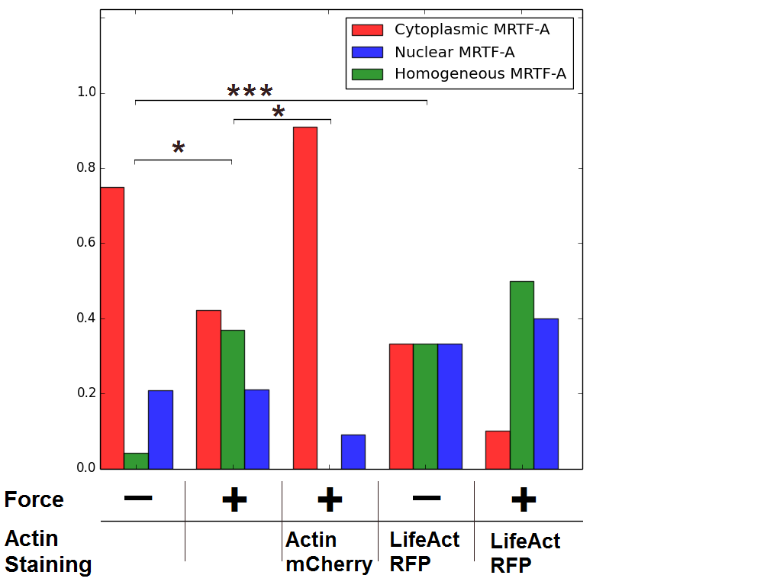
Figure 1 Final state of MRTF-A localization in cells subjected to 1nN force through a fibronectin-coated adherent microbead. The force was applied for 125 seconds repeated 6 times. Number of cells : 29 for the control, 23 with force, 11 with mCherry actin and force, 10 for control with LifeAct and 6 for force with LifeAct. P values were calculated with Fisher’s exact test (*: p<0.05, **:p<0.01, ***:p<0.0001). 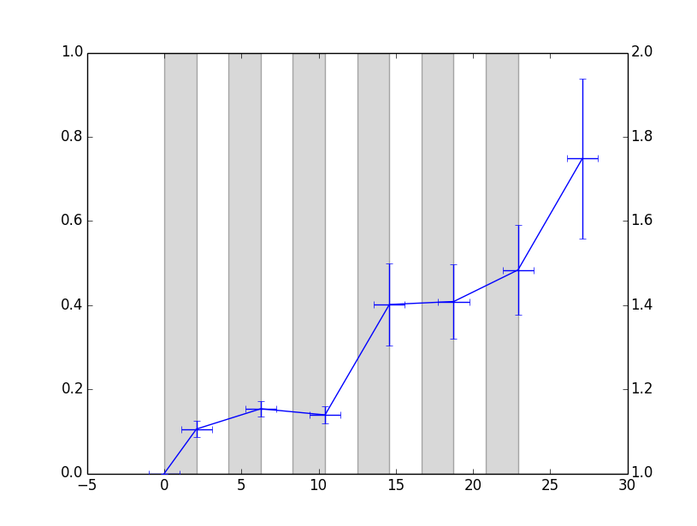
Figure 2 Increase of LifeAct fluorescent intensity around beads subjected to repeated force as compared to the whole cell (6 cells). Mettre 1 point toutes les 4 min et mettre un 2e axe des ordonnées avec la force.
The first experiments were performed using magnetic tweezers which apply a 1nN force on an adherent superparamagnetic microbeads (4.5µm diameter) coated with fibronectin. The force was applied for 2 minutes, and then released for 2 minutes and this cycle was repeated 6 times. The localization of MRTF-A GFP was observed at the end of each force application. The final localization of MRTF-A in different experimental conditions is shown on figure 3. Initially the localization of MRTF-A is not significantly different in any of the condition, though the mCherry actin expressing cells already display a more cytoplasmic localization (not shown). At the end of 6 cycles of force application, MRTF-A is significantly more nuclear in mechanically stimulated cells as compared to control cells, as expected if the 1nN applied force promotes F-actin polymerization. This effect can be blocked by overexpressing actin through mCherry actin co-transfection, most probably because the larger G-actin pool cannot be efficiently depleted by force-induced F-actin polymerization. In order to visualize increased actin polymerization in response to force, fluorescent LifeAct was co-transfected with MRTF-A GFP. Unfortunately, LifeAct had a strong F-actin stabilizing effect in our cells, causing MRTF-A to accumulate in the nucleus even in the absence of mechanical stimulation (see Fig. 3). However, a marked increase of LifeAct fluorescence intensity was measured around beads subjected to repeated forces, with actin forming a ring at the attachment zone, similarly to what was previously observed on the same cell type expressing GFP-actin with RGD-coated microbeads actuated with optical tweezers (Icard 2008).
Trouver une transition entre les pinces et l’étirement.

Global cell stretching changes actin polymerization state and MRTF-A sub-cellular localization
Cells were seeded on stretchable PDMS disks coated with fibronectin, and subjected to 0 to 30% static strain starting at time t=0. They could then either be fixed for further staining and observation after some time of stretching, or observed live to follow the changes in localization of MRTF-A through time after the start of stretching. Two different strain rates were explored, a moderate strain of 10% increase in area and a higher 30% strain.

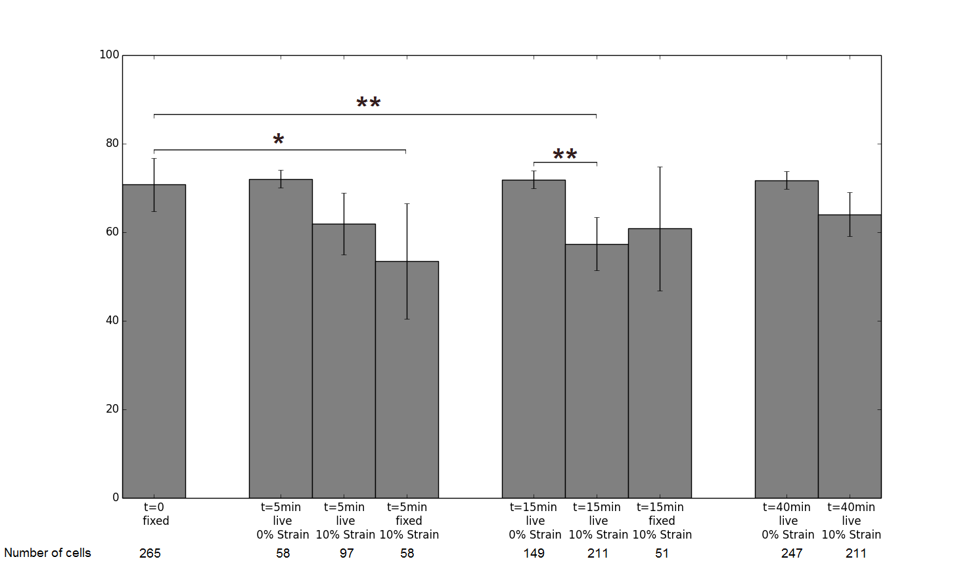
Figure 3 Proportion of cells where MRTF-A is mainly cytoplasmic at different times after the start of stretching. Ajouter les p-values.
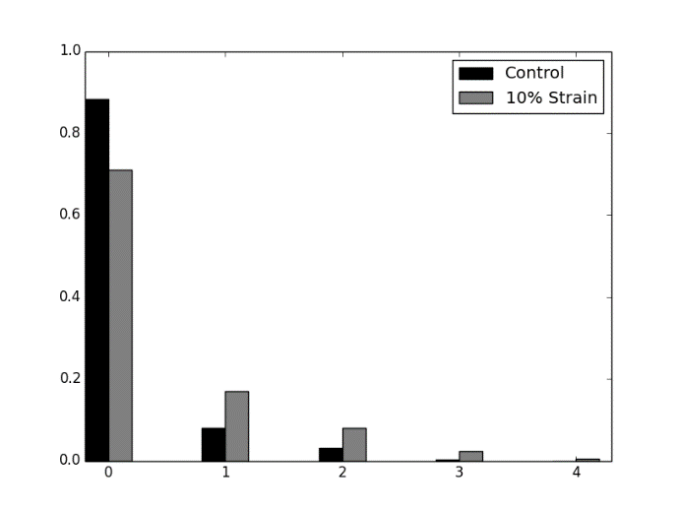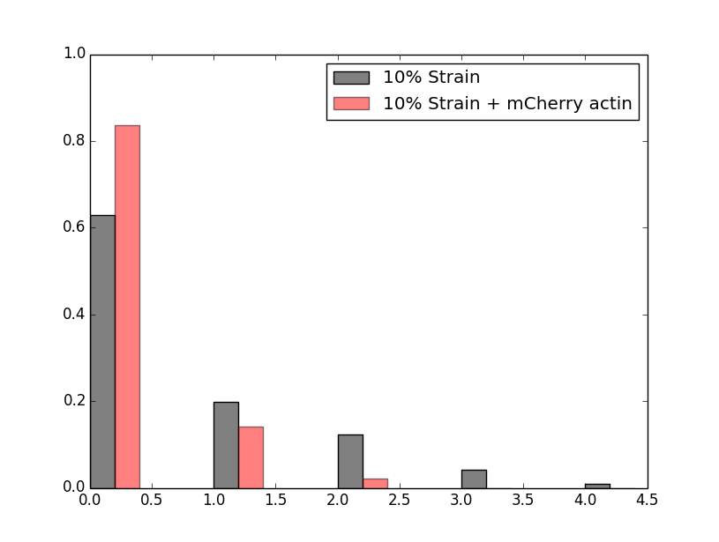
Figure 4 Proportion of cells experiencing 0 to 4 changes in MRTF-A main localization during the 120 minutes of observation (a) 10% strain (211 cells) vs control (249 cells); the two populations significantly differ p=2.10-5 (G-test); (b) 10% stretching, with or without co-transfection with mCherry actin. The two populations significantly differ p=2.10-4 (G-test).

The proportion of cells displaying a cytoplasmic localization of MRTF-A after 5, 15 and 40 minutes of stretching are shown on figure 5. A decrease in cytoplasmic localization under stretch is observed. For experiments in which cells were fixed, this decrease is significant as soon as 5 minutes after starting the stretch, whereas it is not for live experiments, presumably because the number of cells observed at that time is too low. However, at 15 minutes, with more cells, live experiments also show a marked decrease in cytoplasmic localization of MRTF-A. This is consistent with a mechanically-induced polymerization of actin which depletes the G-actin pool, causing MRTF-A to relocate to the nucleus.. During live experiments, the rate of changes in localization of MRTF-A can also be measured, for example by counting the number of times the state of a given cell changes (between “C”, “H” and “N”) for the 120 minutes of observation. The results are displayed in figure 6: the number of cells exhibiting a relocation of MRTF-A is significantly higher when stretching. Repeating the same 10% Strain experiment on Nanofectin-transfected cells with a higher MRTF-A pool, we observed a nuclear accumulation at longer timescales, up to a minimum in cytoplasmic localization of roughly one cell out of three around 90 minutes after stretching. No specific time after stretching appeared for nuclear accumulation, with events occuring regularly from the start of observation (about 10 minutes after stretching) up to 100 minutes after stretching.
The actin polymerization levels were monitored either by staining after fixation or using SiRactin on live cells. On figure ?, the live SiRactin monitoring reveals two quick bursts of polymerization in response to strain, followed by a marked increase in polymerization levels after one hour of stretching. The polymerization levels are consistent with both the short term, and long term nuclear accumulation of MRTF-A described previously, where higher polymerization of actin is linked to more nuclear localization of MRTF-A. At a finer level of detail, an actin cap of highly organized stress fibers s is built above the nucleus as fast as 5 minutes after stretching, during the first burst of actin polymerization. This actin cap is similar to the one described previously by Chambliss & al 2013 for fibroblasts subjected to shear stress.
We had two different ways to try and observe a more radical effect of the mechanics on MRTF-A localization: adding more MRTF-A so that the cells have a smaller G-actin pool, or applying a greater strain.
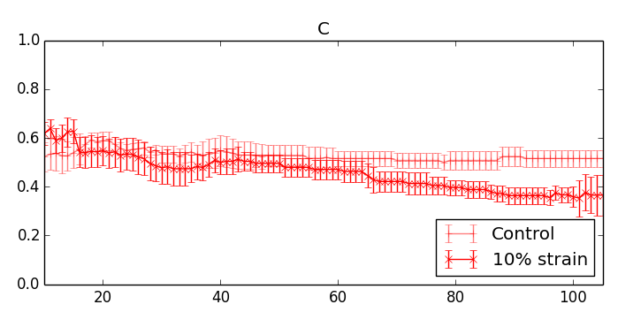Figure 5: Proportion of cells with cytoplasmic MRTF-A through time after applying 10% strain at t=0 versus control.

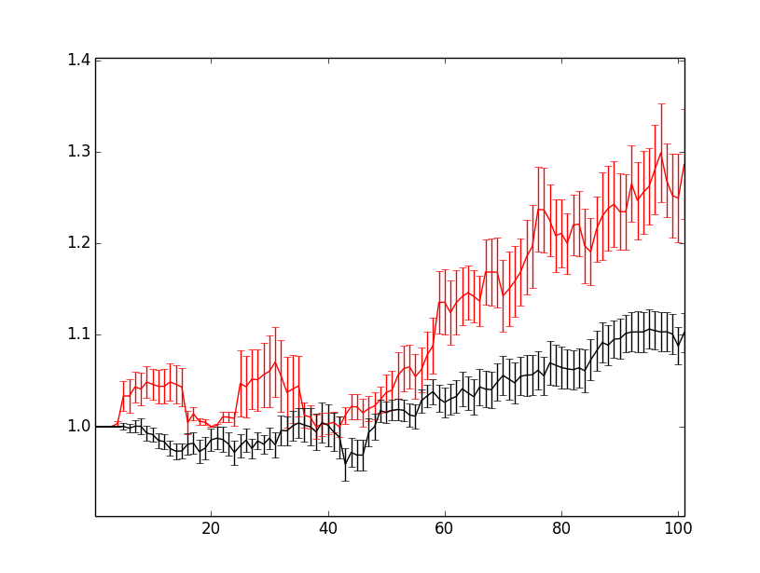Figure 6: Mean of the SiRactin intensity relative to the initial fluorescence level, followed through time after the start of stretching. (10% Strain : n=3, 93 cells, Control : n=n=2, 124 cells)
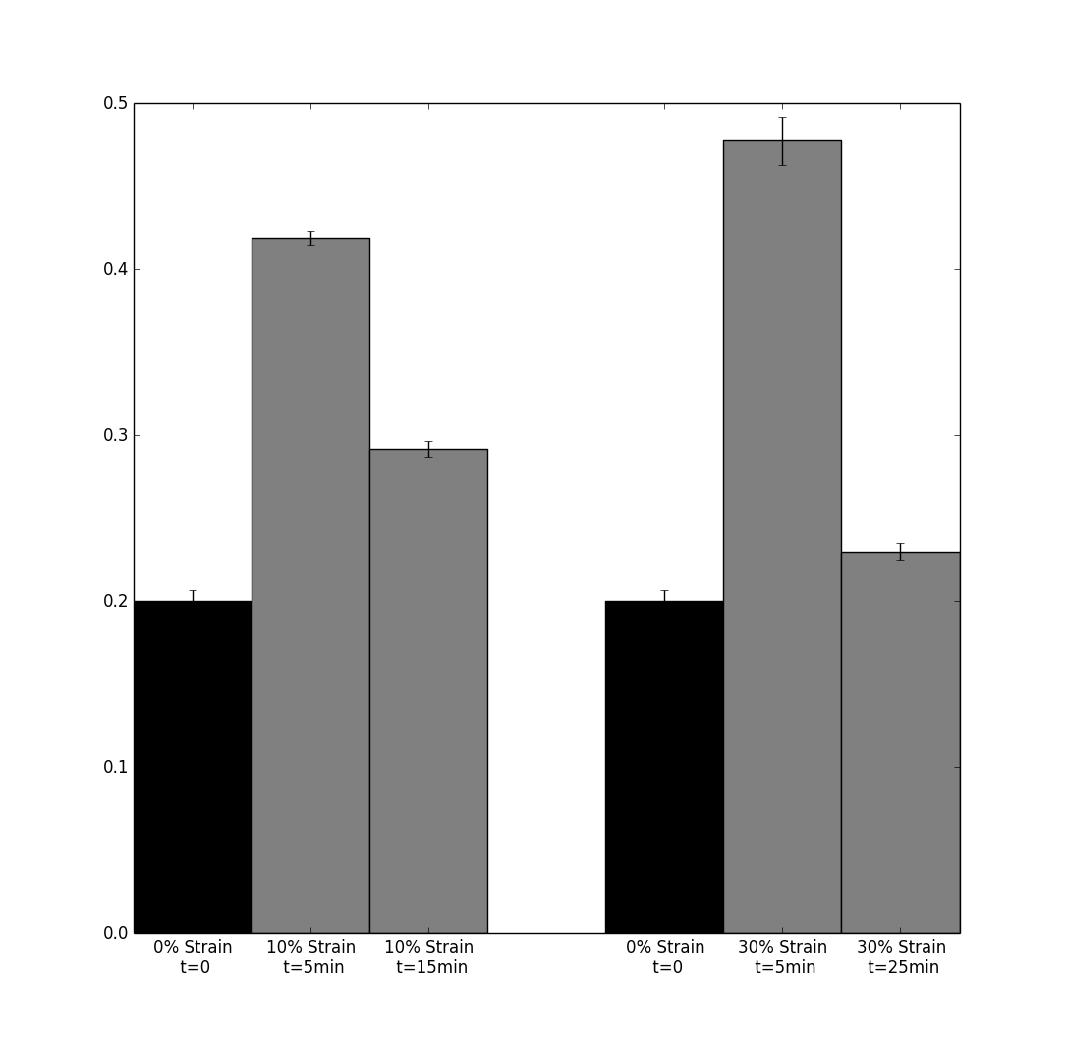Figure 7: Number of stress fibers above the nucleus, rescaled by the nucleus size (diameter in microns). (Control : 38 cells, 10% - t=5min : 66 cell, 10% - t=15min : 55 cells, 30% - t=5min : 50 cells, 30% - t=25min : 41 cells)
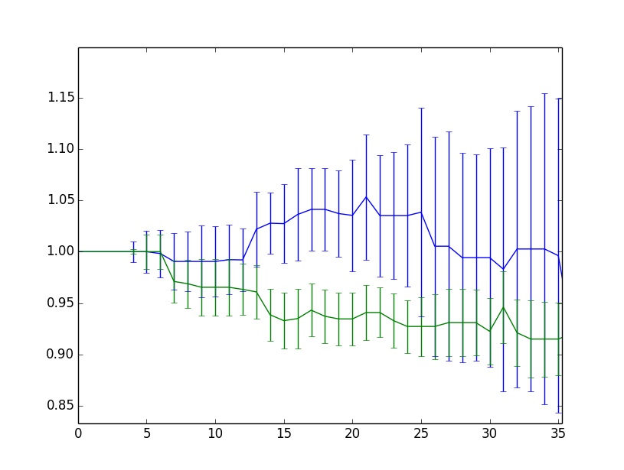Figure 8: Median SiRactin mean intensity relative to the initial fluorescence level. (Control : n=3, 51 cells, 30% Strain : n=4, 108 cells)

The nuclear accumulation seems more durable and more important than for lipofectamin-transfected cells, consistently with higher MRTF-A to G-actin ratio. Dynamically, there is no significant difference in the number of relocation per cell between nanofectin and lipofectamin transfected cells. However, cells with mainly cytoplasmic MRTF-A accumulates MRTF-A in the nucleus more often when nanofectin is used, as expected when the G-actin pool is easier to deplete, and cells with mainly nuclear MRTF-A expel it less often, as expected when MRTF-A is overexpressed. Altogether, a mechanical stimulation of 10% strain can induce nuclear accumulation of MRTF-A in myoblasts, and the scarcer the G-actin, the easier and more durable this effect can be. On the contrary, when mCherry actin is co-transfected with MRTF-A, the nuclear accumulation and its dynamics is completely abolished, as the G-actin pool is much larger.

Stretching at higher strain rates was expected to induce more polymerization of actin and a stronger nuclear accumulation of MRTF-A. However, though the initial response at t=5 minutes seems to be close to the one previously observed with 10% strain, the following events are very different. The nuclear accumulation at t=5minutes does not last, and is followed by a nuclear expulsion, so that at t=40 minutes the localization of MRTF-A is identical to the one of non-stretched cells. At longer timescales (t=80minutes), the cytoplasmic localization of MRTF-A is higher in cells subjected to 30% strain. The number of relocating cells is not significantly different than for 10% strain, but the relocation events are more often MRTF-A accumulating in the cytoplasm instead of in the nucleus. Unlike the events at 10 % strain, that where uniformly distributed though time, the nuclear expulsion events are synchronised between 20 and 40 minutes after the start of stretching, with a peak at t=30min, indicating that the cells all start depolymerizing their cytoskeletton together.

When SiRactin is added ,significantly less MRTF-A is relocated to the cytoplasm, showing that the actin stabilization effect of the marker still has an influence on the cytoskeleton by preventing the mechanically induced depolymerization. The actin cap is built after 5 minutes of stretching, as observed with 10% strain. However, during live SiRactin experiments, SiRactin levels decreased significantly during the first 10 to 15 minutes after stretching, and stays low after that, even if the stabilizing effect of SiRactin probably dampens the process. Alongside the depolymerization, cells also became smaller after 20 to 30 minutes of stretching, pointing towards a loss of adhesion to the substrate at higher and unsustainable strains.
Discussion

The actin cytoskeleton and the localization of MRTF-A were observed when submitted to two different mechanical stimulation protocols, one cyclic and local and one static and global. In both cases, mechanical cues alone are demonstrated to be enough to reorganize the actin cytoskeleton and cause changes in the intra-cellular localization of MRTF-A.
When submitted to a cyclic and local force delivered by magnetic tweezers, the actin cytoskeleton polymerizes around the bead. This result was expected as it is similar to previous reported, in live as well as in fixed cells (Icard 2008,Zhang 2010). In a significant number of cells, the force application induced enough actin polymerization to deplete the G-actin pool, thus promoting the relocation of MRTF-A-GFP to the nucleus within 30 minutes. This relocation can be blocked by preventing the depletion of the G-actin pool, for example by over-expression of mCherry actin, or enhanced by promoting actin polymerization, such as with LifeAct RFP cotransfection. The blocking effect of mCherry actin tranfection confirms the major role of the G-actin pool in the regulation of MRTF-A shuttling : mCherry actin is not expected to have a major influence on F/G ratio, nor on the polymerization rates (even though it is known to be less polymerizable), however, it will increase the monomeric actin pool, and thus favors the cytoplasmic localization of MRTF-A.
When submitted to a moderate global static strain (10% increase in area), the actin cytoskeleton and the localization of MRTF-A display a short term and a long term response to the mechanical stimulation. At first, within 5 minutes, the polymerization of actin increases, and Z-stacks images obtained by confocal microscopy reveal new and highly organized actin stress fibers above the nucleus of the streched cells, similar to the actin cap observed for shear stress (Chambliss 2013). This initial actin recruitment in filaments depletes the G-actin pool, and MRTF-A starts to accumulate in the nucleus, but does not last. At longer timescales, actin polymerization increases more steadily, accompanied by nuclear accumulation of MRTF-A. As in magnetic tweezers experiments, over-expression of mCherry actin blocks the nuclear accumulation process by increasing the G-actin pool. New investigations will be necessary to understand the meaning and the mechanisms of this double timescale in actin polymerization.
At higher strains, such as 30% increase in area, the actin cytoskeleton is pushed to its limits. The short term response is very similar to the moderate strain response, however, from 15 minutes after stretching, the cells starts shrinking and loosing adhesion, along with a depolymerization of the actin cytoskeleton. The increase in G-actin promotes the sequestration of MRTF-A in the cytoplasm and its expulsion from the nucleus. Whether the short nuclear accumulation 5 minutes after stretching is sufficient to activate the target genes of MRTF/SRF remains to be determined.

The mechanisms of regulation of the intra-cellular localization of MRTF-A were mainly studied though serum-stimulation. They involved mainly the RhoA pathway which promotes actin polymerization through both activation of formins and deactivation of cofilin, and phosphorylation of MRTF-A by ERK. MICAL-2, which can oxidize actin and depolymerize it, has been recently proposed as a new player in the regulation of MRTF-A. Here we show that the process can be induced through mechanical stimulation alone, static or cyclic, global or local. Experiments with over-expression of actin confirms that the status of the G-actin pool is the main determinant of MRTF-A intra-cellular localization, and that actin polymerization is efficient only when it is able to deplete it. Next steps include investigations about the signalization pathway between the mechanical stimulus through integrins and the actin polymerization, with the RhoA pathway as a major target, but also investigations about a possible role of MICAL-2, suggested by our observations of measurable decrease in nuclear G-actin in response to moderate strains. With live experiments, different timescales of response were observed, and the question of the dynamics of SRF target genes is now to be addressed : how long does MRTF-A have to stay in the nucleus for the gene program to be activated ? Will the target genes be different when MRTF-A stays longer in the nucleus ?
SiRactin proved to be a most useful too to investigate live actin dynamics, as it required no transfection, was equally distributed between all cells, and has the least influence over actin dynamics among the different actin markers tested. However, even in very reduced amount, it seems to have a subtle stabilizing effect on actin filaments in our experiments.

